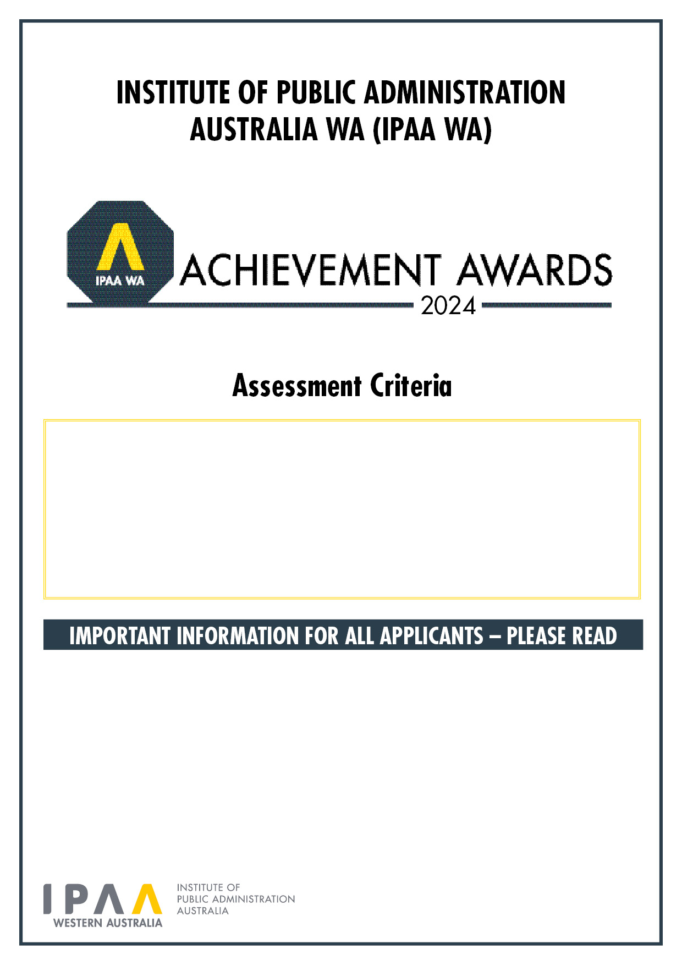

* Please do not exceed the maximum word count per criteria (additional words will not be considered).
* **Each Criteria is placed on a separate page.** This award has 4 Criteria (C1 to C4) - ensure you address all criteria.
* If you are including graphics/images/tables, we ask that you do not exceed a page count for that particular criteria, based on 500 words per page as a guide (e.g. if the criteria is 1,000 words, this would give you two pages maximum).
* Please keep the default size 11 Arial font when addressing the criteria.
* Once you have addressed all criteria in this form, please upload this document via the online Entry Form: <http://www.wa.ipaa.org.au/Achievement-Awards-Entry-Form.aspx>
* Email [awards@ipaawa.org.au](mailto:awards@ipaawa.org.au) or phone 08 9360 1400 for enquiries or assistance completing the Assessment Criteria.

**Leader of the Year in Local Government**

Criteria 1: Weighting - 10 | Maximum 300 Words

# C1: Provide a summary of the nominee’s leadership philosophy and the principles they bring to their organisation.

Criteria 2: Weighting - 30 | Maximum 700 Words

# C2: Outline how the nominee has achieved significant strategic outcomes for their organisation.

Criteria 3: Weighting - 50 | Maximum 1000 Words

# C3: Describe how the nominee has demonstrated excellence in public administration and leadership throughout their career, focusing on recent years, including how the nominee promotes, encourages, and/or develops other leaders and managers.

Criteria 4: Weighting - 10 | Maximum 300 Words

# C4: Using examples, demonstrate how the nominee’s organisation exhibits best practice in public administration as a result of the nominee’s leadership.